ETL Project
Brexit Referendum 2016 VS. UK Election Results in 2019

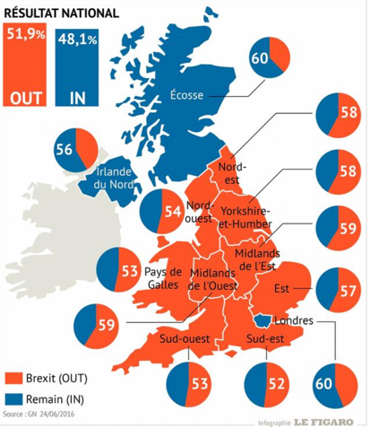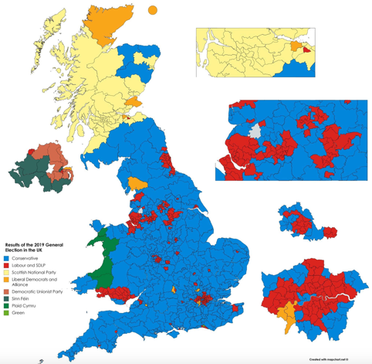

Group 5
Team Members: Alexis Lawal, Arnold Macamos, Ekamjit Deol, Nazain Azari

Abstract: On the 12th of December, the UK's voting public went to the polls for the fourth time in five years. Results have been declared in all 650 constituencies. The Conservatives won the election with 365 seats, a majority of 39. Group five would like to compare the share of 2019 Conservative votes in different constituencies to the Brexit referendum, which took place on 23 June 2016. Group five hopes to find any constituency that made a shift to or from the Pro-Brexit Conservative Party. We hope to discover the reasoning behind the vote shift in those constituencies and track the possible effects of Brexit on the voting public.

Resources:
We will scrape data from the following resources:

For 2019 UK. Election Result:
BBC News
Constituencies A-Z - Election 2019
Find the latest news and election results in your constituency from BBC

For 2016 Brexit Referendum:

The Electoral Commission

PROJECT REPORT

I. Data Model

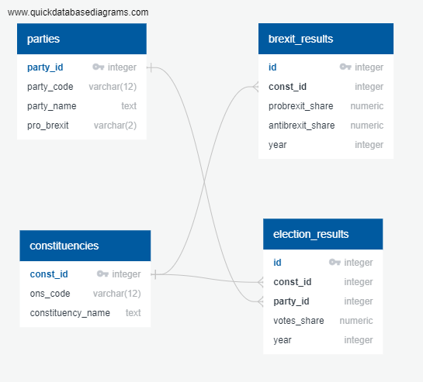

II. Data Table Definition

Table Name: parties (List of UK Parties)
Field Name | Description
Party_id | This is the primary key. Starting from 1 incremented by 1
Party_code | i.e. CON, LIB, IND
Party_name | Party name in long format (i.e. Conservative, Liberal, Independent)
Pro_brexit | Y – if pro Brexit, N – if anti brexit

Table Name: constituencies (List of UK Constituencies)
Field Name | Description
Const_id | This is the primary key. Starting from 1 incremented by 1
Ons_code | Constituency code
Constituency_name | Constituency name

Table Name: Brexit_results ( Brexit results data)
Field Name | Description
id | This is the primary key. Starting from 1 incremented by 1
Const_id | Reference id from “constituencies” table
Probrexit_share | %share of election votes that are considered pro Brexit
Antibrexit_share | %share of election votes that are considered anti Brexit
year | The year the election was held

Table Name: election_results (UK Election results data)
Field Name | Description
id | This is the primary key. Starting from 1 incremented by 1
Const_id | Reference id from “constituencies” table
Party_id | Reference id from “parties” table
Votes_share | % share of votes by constituency and by party
year | The year the election was held

III. Suggested Application

To create an application that will do the data gathering, formatting, and populate each and every database table with these data.

The following are the steps the application should performed
- Clear database records
- ETL of parties information with CSV file
- ETL of constituencies information with CSV file
- ETL of UK Brexit results with CSV file
- ETL of UK Election results through Web Scraping

